Strategic Domestic Abuse Team 16 Days of Activism 2026
For Wakefield District Professionals
16 Days of Activism Against Gender-Based Violence is a global campaign from 25th November to 10th December.
25th November is White Ribbon Day.
Join the 16 Days of Activism. Together we can raise awareness, support survivors, challenge harmful attitudes, and take action to end domestic abuse and violence against women and girls. Further details will be shared or contact DAforum@wakefield.gov.uk 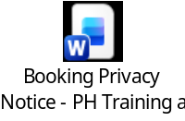
Wednesday 25th November 2026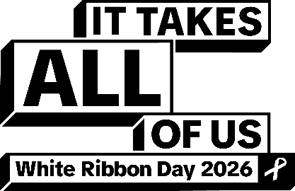  Visit the White Ribbon stand in Wakefield One Atrium 11.00 -3.00  PM: DA Strategy Drop-in 2-5pm – Stanley Street (Wakefield) | Thursday 26th November 2026    Wear something orange to work to mark 16 Days of Activism  AM: Domestic Abuse Management Board 9:30-1:00  PM: Tom Regan Pol-Ed Public Health Briefing 1:30-2:00 | Friday 27th November 2026  Teams link- White Ribbon awareness webinar for Wakefield Council employees  10.00-10.30    Wakefield Market stall (Public) Wakefield Domestic Abuse Support Service | Saturday 28th November 2026  Wellbeing Day    Adult mental health support - Wakefield Council  Homepage - National Domestic Abuse Helpline  Wakefield Domestic Abuse Support Service (Wakefield DASS) - Wakefield Council
Sunday 29th November 2026  Wellbeing Day   | Monday 30th November 2026  Teams Link - The links between Domestic Abuse and Suicide  1.00-1.30  Teams link- White Ribbon awareness webinar for Wakefield Council employees  3.00-3.30  DA Strategy Online drop in 2.00-3.30pm | Tuesday 1stDecember 2026  Pol-Ed F2F session for School Leaders 2:15-3:15  Adolescents and Domestic Abuse - Sam Fry  WDASS 3.30-4:30  Book on Eventbrite: https://www.eventbrite.co.uk/e/2003502029503?aff=oddtdtcreator    DA Strategy drop in Cedars Children’s Centre  9.30am-12pm (South East) | Wednesday 2nd December 2026  Guest Speaker David Challen  11.00-12.00  Book on Eventbrite: After The Unthinkable: The Impact of Coercive Control on Children  David Challen | Author, Campaigner and Speaker  DSL Forum- CYP offer /Cranstoun /Pol-Ed  3.30- 5.30  DA Strategy Online drop in  1.30-3.00 pm
Thursday 3rd December 2026  Launch of DASH Training  Guest Speaker Colin Fitzgerald Q&A  Head of Domestic Abuse Services  11:30- 12:30  Teams link -Guest Speaker Head of Domestic Abuse Services Colin Fitzgerald Q&A    DA Strategy 10.00-11.30 am Online drop-in | Friday 4th December 2026  Castleford Market stall (Public) Wakefield Domestic Abuse Support Service  Coercive Control -Eggshells  https://canva.link/aa0zthsndz67n8v | Saturday 5th December 2026  Wellbeing Day   | Sunday 6th December 2026  Wellbeing Day    Review 16 Days of Activism 2026 and help us plan for 2027  
Monday 7th December 2026  Trauma Informed Support – Sam Fry WDASS  3:30-4:30  Book on Eventbrite: https://www.eventbrite.co.uk/e/2003592226284?aff=oddtdtcreator | Tuesday 8th December 2026  Visit the White Ribbon stand in Wakefield One Atrium 11am -3pm    DA Strategy Drop-in 10-12pm Airedale Hub | Wednesday 9th December 2026  Awareness Input on Sexual Misconduct and Abuse of Position for a Sexual Purpose (APSP)  Teams link - Presentation from Vicky Foley, Counter Corruption Unit  11.00-12.00 (For Wakefield District Partners)   | Thursday 10th December 2026  Come and meet the service- Wakefield Domestic Abuse Support Service (WDASS) Event  Session one 11am/ Session two 12:30 (with lunch)  For Wakefield District CYP Practitioners  Sign up by Eventbrite (To follow)

