



UTI prevention and awareness toolkit

Version: October 2023

## About this toolkit

The UK Antimicrobial Resistance (AMR) National Action Plan (2019-24) has a set target to halve the number of Gram-negative bloodstream infections by 2024, in an effort to contain and control infection and antibiotic use to help reduce antimicrobial resistance.

A large proportion of bloodstream infections are caused by E. coli bacteria, which is the predominant cause of urinary tract infections (UTIs) and which can lead to severe infection in older adults living in the community.

Therefore, the UK Health Security Agency (UKHSA) and NHS England (NHSE) are running a joint campaign to raise awareness of UTI prevention, symptom recognition and treatment including advice on how and when to seek help.

This campaign will be targeted at:

1. **Older adults (65 years +)** who are at higher risk of the impacts of urinary tract infections

#### Paid and unpaid carers

The content included in this toolkit can be used to target both audiences.

## Successful management of UTIs

Successful management of UTIs requires a coordinated focus on prevention, early and accurate diagnosis, and appropriate treatment. If left unmanaged, UTIs can lead to severe infection, sepsis and in some cases death.

* + Antibiotics can be lifesaving, but antibiotics are not always needed for urinary symptoms. It is important for people to only take antibiotics for a UTI if they are needed. This is because taking antibiotics can cause side effects, for example nausea and diarrhoea and can damage the ‘friendly’ bacteria that normally live in the intestinal tract and the skin and protect us from infection.
  + Taking antibiotics when they are not needed can also make the bacteria that cause infections to become resistant to that antibiotic, meaning that the antibiotic might not work if it is needed for a true infection in the future.
  + Antibiotics should only be taken if a healthcare professional prescribes them for that infection. Antibiotics should always be taken as directed on the medicine label.
  + A healthcare professional may prescribe a short course of antibiotics if a UTI is confirmed. Three-day courses of antibiotics are usually effective for women, but a longer course is needed for men or those with a urinary catheter.

## People at risk of the impacts of a UTI

* + UTIs and catheter associated UTIs are one of the leading causes of E. coli and Gram-negative bloodstream infections and are a significant cause of death and serious illness, **especially amongst the older population.**
  + Older adults are more likely to be admitted to hospital with a UTI.
  + To ensure an accurate diagnosis in older adults, avoid using urine dipsticks to check for a UTI, as they become more unreliable with increasing age. This is especially true for adults living in care homes and those with a urinary catheter.
  + These groups are at greater risk of having bacteria present in the bladder/urine without an infection. This “asymptomatic bacteriuria” is not harmful, and although it causes a positive urine dipstick, antibiotics are not beneficial and may cause harm.
  + In some cases, a specimen of urine is sent for laboratory testing to inform which antibiotics are needed for treatment.



# A blue and white logo Description automatically generatedKey messages for paid and unpaid carers



## Identifying a UTI: the symptoms

**What is a UTI (urinary tract infection)?**

Urinary tract infections (UTIs) affect the urinary tract, including the bladder, urethra, or kidneys. Sometimes a urinary tract infection can develop into a severe infection that can cause a person to become very ill and they may then need to go to hospital.

**What are the symptoms of a UTI?**

A person with a UTI may have signs and symptoms including:

* Needing to pee more frequently, suddenly, or more urgently than usual.
* Pain or a burning sensation when peeing.
* Needing to pee at night more often than usual.
* New pain in the lower tummy.
* New incontinence or wetting themselves that is worse than usual.
* Kidney pain or pain in the lower back.
* Blood in the pee.
* Changes in behaviour, such as acting agitated or confused (delirium). This could be a symptom of a UTI but could also be due to other causes, which need to be ruled out.
* General signs of infection, like a fever, a high temperature or feeling hot and shivery, with shaking (rigors) or chills.
* A very low temperature, below 36°C.
* A person may experience fewer of these symptoms if they have a urinary catheter.

## Preventing UTIs

* [Support those in your care to drink enough fluids. Regular drinks, like water, boost hydration. The NHS Eatwell Guide recommends that people should aim to drink 6 to 8 cups or glasses of fluid a day. Water, lower-fat milk](https://www.nhs.uk/live-well/eat-well/food-guidelines-and-food-labels/water-drinks-nutrition/) and sugar-free drinks, including tea and coffee, all count.
* Sometimes people don’t like to drink as they are worried about getting to the toilet. If someone you care for is less able to access the toilet, ensure they are provided with support to do so at regular intervals, so that they feel confident to keep well by drinking enough. If needed, a continence professional can support with a continence assessment.
* Help might include choosing the right type of drink that they like, at the right temperature, in the right kind of cup or

glass.

* Support those you care for to keep the genital area clean and understand the importance of personal hygiene, showering daily where possible, especially if they suffer from incontinence.
  + Check and change incontinence pads often. If they are soiled, they should be changed right away.
  + Wipe from front to back when they go to the toilet.
  + Avoid using irritating products such as scented soaps, gels, and sprays around the genital area.
* Avoid the use of urinary dipsticks to diagnose UTIs in older adults and those with urinary catheters as they are unreliable. In some cases, a specimen of urine is sent for laboratory testing to inform which antibiotics are needed for treatment.

### Preventing UTIs for those with indwelling catheters

If someone you care for has an indwelling urinary catheter, a thin hollow flexible tube inserted into the bladder to drain urine, we recommend the following advice:

1. Wash your hands with soap and water every time before and after touching the catheter and any equipment attached to it.
2. If possible, make sure people with a catheter have a daily shower with their bag or valve attached.
3. If it is not possible to have a shower, ensure you wash the skin in the area where the catheter enters the body with unscented soaps or gels and water at least daily.
4. For men, it is important to wash under the foreskin, replacing afterwards, unless circumcised.
5. After using the toilet, wipe front to back with toilet tissue, to avoid moving poo from the bottom to the catheter.
6. Urinary catheter use comes with a risk of infection, in fact for every day the catheter stays in the risk of infection increases. Therefore, long term use should be avoided wherever possible. Discuss other options with a healthcare professional and ensure that people who use them are regularly reviewed by their doctor or a continence nurse.

## Taking action

**What should you do if you think someone you care for has a UTI?**

* + Contact a healthcare professional, this could be the local GP, a senior nurse, the community pharmacist, walk-in centre or NHS 111 service if you think someone you care for may have a UTI.



# A blue and white logo Description automatically generatedKey messages for older adults



## Identifying a UTI: the symptoms

**What is a UTI (urinary tract infection)?**

Urinary tract infections (UTIs) affect your urinary tract, including your bladder, urethra, or kidneys. Sometimes a urinary tract infection

can develop into a severe infection that can cause you to become very ill and you may then need to go to hospital.

**What are the symptoms of a UTI?**

Here are some signs and symptoms you may experience if you have a UTI:

* Needing to pee more frequently, suddenly, or more urgently than usual.
* Pain or a burning sensation when peeing.
* Needing to pee at night more often than usual.
* New pain in the lower tummy.
* New incontinence or wetting yourself that is worse than usual.
* Kidney pain or pain in the lower back.
* Blood in the pee.
* Changes in behaviour, such as acting agitated or confused (delirium). This could be a symptom of a UTI but could also be due to other causes, which need to be ruled out.
* General signs of infection, like a fever, a high temperature or feeling hot and shivery, with shaking (rigors) or chills.
* A very low temperature below 36°C.
* You may experience fewer of these symptoms if you have a urinary catheter.

## Preventing UTIs

These things may help prevent you from getting a UTI:

* [Drinking enough fluids. Regular drinks, like water or squash will boost hydration and help your body stay healthy. The NHS Eatwell Guide recommends that people should aim to drink 6 to 8 cups or glasses of fluid a day. Water, lower-fat milk and](https://www.nhs.uk/live-well/eat-well/food-guidelines-and-food-labels/water-drinks-nutrition/) sugar- free drinks, including tea and coffee, all count.
* Regularly drinking may mean more trips to the toilet. If you are having difficulties getting to the toilet or worried about incontinence discuss this with your doctor or a nurse who will be able to help you. Don’t reduce the amount you drink.
* Not holding onto your pee, go to the toilet as soon as possible when you need to.
* Keeping up with personal hygiene. Wash, or shower daily where possible especially if you suffer from incontinence.
* Keeping the genital area clean and dry
  + Check and change incontinence pads often. If they are soiled, they should be changed right away.
  + Wipe from front to back when you go to the toilet.
  + Avoid using irritating products such as scented soaps, gels, and sprays around the genital area.
* Washing the skin around the genitals with water before and after sex.
* Going for a pee as soon as possible after sex.

### Preventing UTIs for those with indwelling catheters

If you have an indwelling urinary catheter, a thin hollow flexible tube inserted into the bladder to drain urine, we recommend the following advice:

1. Wash your hands with soap and water every time before and after touching the catheter and any equipment attached to it.
2. If possible, make sure you have a daily shower. Do this with your bag or valve attached.
3. If it is not possible to have a shower, ensure you wash the skin in the area where the catheter enters the body with unscented soaps or gels and water at least daily
4. For men, it is important to wash under your foreskin, replacing afterwards, unless circumcised.
5. After using the toilet, wipe front to back with toilet tissue, to avoid moving poo from your bottom to the catheter.
6. Urinary catheter use comes with a risk of infection, in fact for every day your catheter stays in the risk of infection increases. Therefore, long term use should be avoided wherever possible. Discuss other options with your healthcare professional.

## Taking action

#### What should you do if you think you have a UTI?

* + If you think you might have a UTI, ensure you are drinking enough fluids to avoid becoming dehydrated. Take paracetamol up to four times a day to reduce any pain.

#### Who to contact

* + Contact a healthcare professional if you think you might have a UTI, this could be your GP, a nurse, the community pharmacist, a walk-in centre or the NHS 111 service.

#### Treatment

* + There are different treatment options to discuss with your healthcare professional. Antibiotics should only be taken if prescribed by a healthcare professional. Always ensure antibiotics are taken as directed on the medicine label.

## Examples of the assets available to download

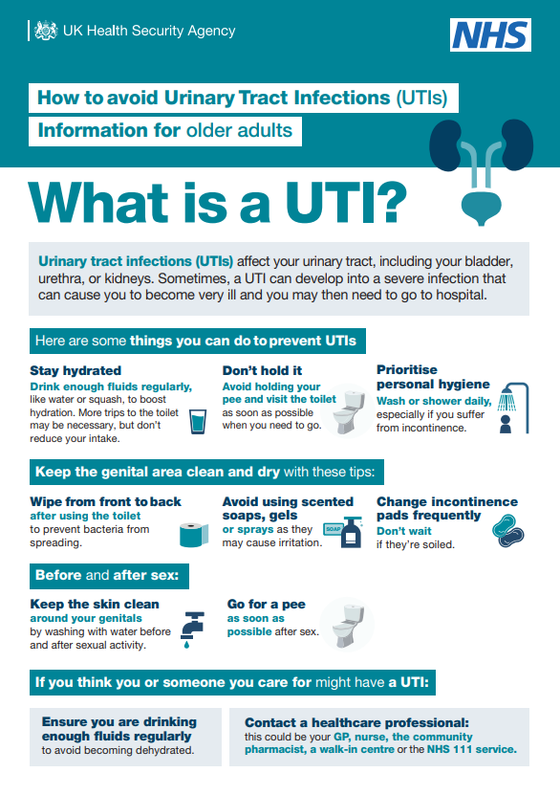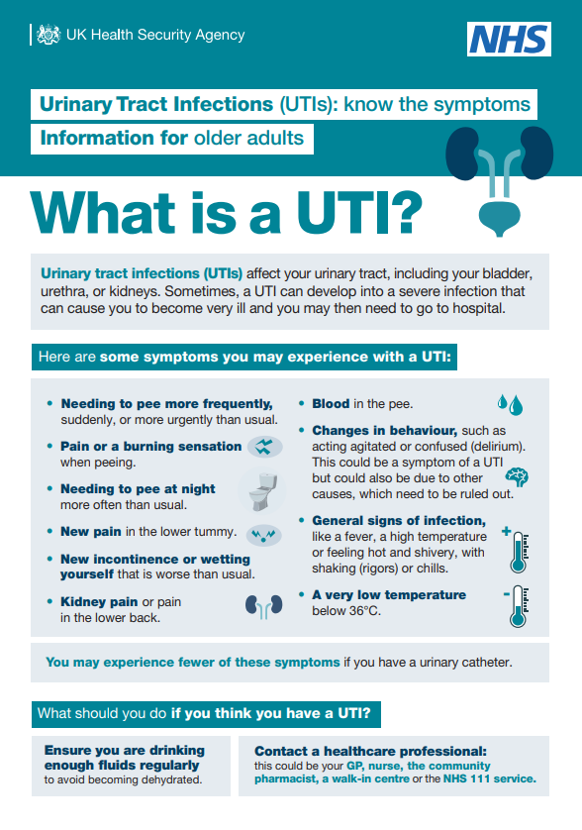

## Social media content and posters

#### UKHSA and NHSE assets

We welcome your support of this campaign.

* + We recommend that local authorities and community and voluntary sector organisations share our posts or issue your own social media updates.
  + Posters are also available to download and print for care settings.
  + Download [social media assets and posters](https://drive.google.com/drive/folders/13AF1r4mXvFjkYRc8ooUJ6wego4qMs3fC?usp=sharing).
  + For more information please direct people to: NHS Urinary Tract Infections webpage: [www.nhs.uk/conditions/urinary-tract-infections-utis/](http://www.nhs.uk/conditions/urinary-tract-infections-utis/)

## Other resources

#### NHSE other resources

* + NHS E. coli prevention video: [www.youtube.com/watch?v=BRHg6yQZLmg](http://www.youtube.com/watch?v=BRHg6yQZLmg)
  + NHS hydration video: [www.youtube.com/watch?v=ljdQxkJtdvY](http://www.youtube.com/watch?v=ljdQxkJtdvY)
  + NHS catheter video: [www.youtube.com/watch?v=TX1QvdL1AeY](http://www.youtube.com/watch?v=TX1QvdL1AeY)
  + NHS To dip or not to dip video: [https://www.youtube.com/watch?v=rZ5T1Cz7DHQ](https://eur01.safelinks.protection.outlook.com/?url=https%3A%2F%2Fwww.youtube.com%2Fwatch%3Fv%3DrZ5T1Cz7DHQ&data=05%7C01%7CAnna.Flanagan%40ukhsa.gov.uk%7C7c860ec24a9a49f4473f08dba9f9469b%7Cee4e14994a354b2ead475f3cf9de8666%7C0%7C0%7C638290660331444321%7CUnknown%7CTWFpbGZsb3d8eyJWIjoiMC4wLjAwMDAiLCJQIjoiV2luMzIiLCJBTiI6Ik1haWwiLCJXVCI6Mn0%3D%7C3000%7C%7C%7C&sdata=6tk2wO6SQzWEPd28EZeoTd5NKX%2FTL7oyQr8CV5BUguk%3D&reserved=0)

#### StOP UTI

* + The ‘StOP UTI’ research project looked at ways to prevent and recognise urinary tract infections in older people living in care homes. There are a number of resources available on their [website which can be found here: www.southampton.ac.uk/research/groups/bladder-bowel- management/preventing-urinary-tract-infections](http://www.southampton.ac.uk/research/groups/bladder-bowel-management/preventing-urinary-tract-infections)



For more information on Urinary Tract Infections (UTI) and how to prevent and treat them, please visit: [www.nhs.uk/conditions/urinary-tract-infections-utis/](http://www.nhs.uk/conditions/urinary-tract-infections-utis/)

