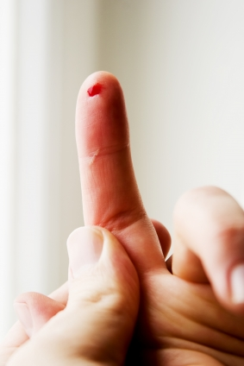**Standard advice and assistance for staff following an inoculation injury**

**First aid following a needlestick injury**

* Make the area safe by disposing of the sharp
* Take off any gloves
* Make the wounded area bleed by squeezing
* Wash it under running water for 1 minute with soap and water – there is no need to use alcohol or other skin cleanser
* Dry the site and cover with a waterproof plaster
* 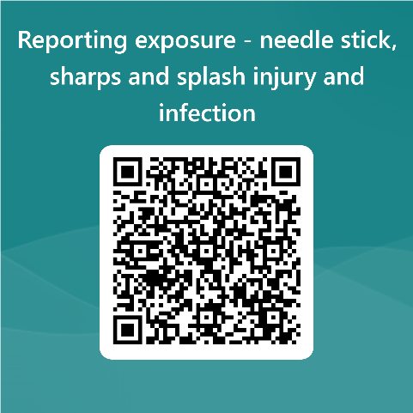Ask the patient to remain in the surgery and give them the “source patient information leaflet” and consent forms. When the forms have been completed contact Imperial Health at Work on **020 3313 7010**, Monday to Friday 09:00 to 16:00 except public holidays or go to your nearest A&E out of hours. Alternatively, report this incident via our web link or QR code below: <https://forms.office.com/e/kS1znKBhuw>

**First aid following a blood splash or body fluid exposure**

* Stop what you are doing.
* Rinse the affected area with ordinary tap water.
* If you have had a splash to the eye, get a colleague to help you rinse the eye for 1 minute.
* If you wear contact lenses, remove them from the affected eye before irrigating.
* **Ask the patient to remain in the surgery and give them the “Source Patient Information Pack NHS England” and consent forms. When the forms have been completed send a scanned copy to** [**imperial.ohdutynurse@nhs.net**](mailto:imperial.ohdutynurse@nhs.net)

**If you attend A&E following a sharps/splash please report to Imperial Health at Work on 020 3313 7010 or email** [**imperial.ohdutynurse@nhs.net**](mailto:imperial.ohdutynurse@nhs.net) **during operating hours.**

You are only at risk if you have a significant exposure to a potentially infected body fluid

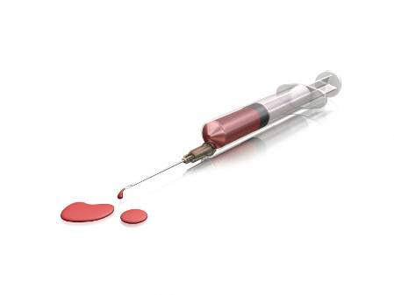

**Occupational exposure**

Inoculation/ prick by used needle, surgical blade, glass, bone or other sharp object

Splash to mucous membrane (eyes/ mouth or nose).

Exposure of non-intact skin such as eczema/ cuts, sores or abrasions

Human bite that breaks the skin

**Infection**

**risk**

**Infected**

**body fluid**

Fresh/ dried blood

Unfixed human tissue

Semen/ vaginal fluid

Cerebrospinal fluid

Blood stained urine or faeces

You are not at risk from blood borne infections if blood or body fluid comes into contact with intact, healthy skin. This is because the top layer of skin has cells that are so tightly packed and thick that these viruses cannot penetrate and enter the blood stream. A needlestick injury punctures this layer potentially allowing infected material to enter the deeper layers and the bloodstream. Also, if you have a sore or cut this can allow infected material to enter the body.

The top layer of skin inside the eyelids, nose and mouth is very thin and not so tightly packed and there is a small chance that viruses in infected blood can pass between the cells here and enter the blood stream.

**What happens when you report your accident to Imperial Health at Work**

* You will be assessed within 90 minutes of the initial report.
* An Occupational Health nurse will assess the risk from blood borne viruses using the information the patient provided on the blood borne virus risk assessment form
* We will assess whether HIV, HTLVor Hepatitis B prophylaxis (PEP) is necessary and make arrangements for it when appropriate.
* Arrangements will be made for you to have blood taken from you for ‘saving’ as it may be required to be tested at a later stage. This will be done at a time and location convenient for you and can happen within 1 week of your accident.
* We will answer any questions or concerns so that you feel reassured and are fully aware of what will happen afterwards.

**Dealing with the source patient**

* Give the source patient a copy of the information leaflet “Testing your blood after sharps injuries and blood or body fluid splashes”.
* When the patient has read the leaflet, ask them to complete the blood borne virus risk assessment form or ask someone else at the practice to go through it with them
* Ask for consent to be given on the consent form on page 2 of the risk assessment form
* The risk assessment form and consent will be discussed with the specialist nurse at Imperial Health at Work.
* Following the consultation, Email the completed consent form to: [imperial.ohdutynurse@nhs.net](mailto:imperial.ohdutynurse@nhs.net)
* If consent is not given, or if the patient wishes to be tested elsewhere please discuss this with the occupational health nurse as alternative arrangements may be required.

**Follow-up**

* You will be offered follow-up testing if the patient is found to be infected with a blood borne virus, where HIV PEP is required or if an untested patient has risk factors.
* In most cases where there are no risk factors but the patient is not tested follow-up is usually not required as the risk of infection is very low. However, those sustaining deep or more extensive injuries or those involving exposure to significant quantities of fresh blood may be offered follow-up.
* Follow-up may include tests for hepatitis B, hepatitis C, HIV or HTLV several times for up to 6 months after the accident and if these are negative after 6 months it is highly unlikely that you have been infected.
* It is your responsibility to report the accident using your surgery’s standard accident reporting procedures. This is in addition to the report to Imperial Health at Work
* Imperial Health at Work may have to complete a form for the Health & Safety Executive if you are exposed to HIV, hepatitis B, HTLV or hepatitis C as this is a legal requirement under RIDDOR regulations.
* Please let Imperial Health at Work know if your blood contaminated the patient’s open wound (e.g. if a dentist bled into the patient’s mouth).

**Post-Exposure Prophylaxis – Important Facts**

Post-exposure prophylaxis against HIV, HTLV and hepatitis B significantly reduces the chances of disease transmission.

In case of exposure to HIV or HTLV infected source, it is recommended that PEP be commenced as soon as possible after the exposure and preferably **within the first two hours** following exposure but can be up to 72 hours post-exposure. The HIV or HTLV PEP treatment regime comprises 2 tablets twice a day for up to 28 days although can be stopped if the patient tests negative for HIV infection. PEP Packs are available in A & E, main theatres, delivery suites and Occupational Health departments.

For hepatitis B exposure, the **PEP can be given up to 1 week** following exposure. Depending on your immune status it may include a hepatitis B vaccination and/ or an injection of immunoglobulin.

There is no immediate prophylaxis for hepatitis C exposure. However, the exposed healthcare worker can be tested for infection at 6, 12 and 24 weeks so that referral for immediate treatment can be made which can improve your chances of clearing the virus.