# **Data Quality Searches to Find Eligible Patients:**

# **Type 2 Diabetes Path to Remission(T2DR) Programme**

# SystmOne Reports

Location of reports:

Go to **Clinical Reporting**

**NW London ICB >> Diabetes T2DR**

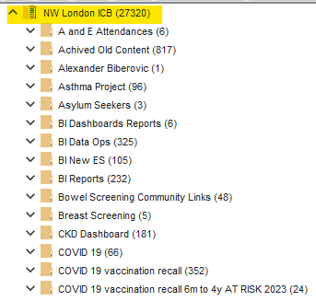

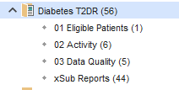

Report in *01 Eligible Patients* provides list of patients who are eligible to be referred for NHS T2DR programme

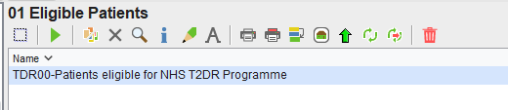

Reports in *02 Activity* provides a list of patients who have been referred, started, completed or not completed NHS T2DR programme. It also provides a list of patients who have had 3, 6 and 12 months follow ups.

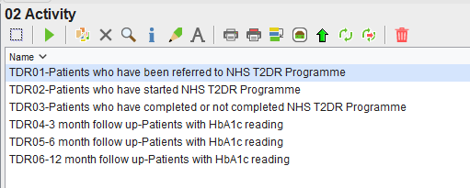

Reports in 03 Data Quality find patients who are missing codes for starting, completing or not completing NHS T2DR programme or missing 3, 6, 12 month follow ups.

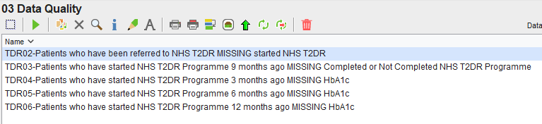

# EMIS Reports

Location of reports

Hillingdon practices & The Confederation: **Hillingdon CCG Search & Reports >> Diabetes T2DR Programme**

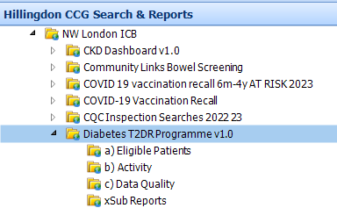

Brent, Harrow practices & all PCNs: **NWL EMIS Enterprise Search & Reports >> Diabetes T2DR Programme**

Please note the version control of the folder and it will be updated if the reports are amended.

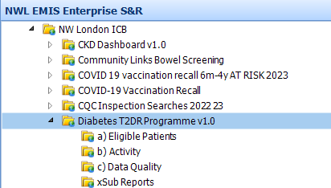

Report in *01 Eligible Patients* provides list of patients who are eligible to be referred for NHS T2DR programme

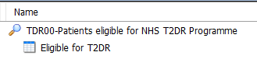

Reports in *02 Activity* provides a list of patients who have been referred, started, completed or not completed NHS T2DR programme. It also provides a list of patients who have had 3, 6 and 12 months follow ups.

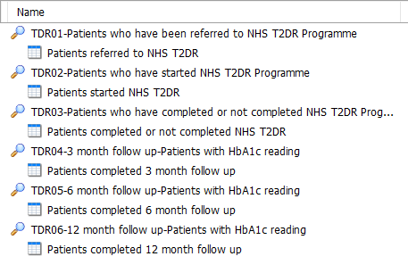

Reports in 03 Data Quality find patients who are missing codes for starting, completing or not completing NHS T2DR programme or missing 3, 6, 12 month follow ups.

