**NWL Digital Weight Management**

**SystmOne**

**Referral Wizard:**

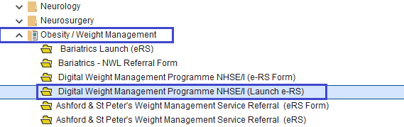

**Referral Form:**



**EMIS**

**Referral Form:**

