Primary care immunisation update webinar series 2024 – a free training resource for immunisers in London Developed and provided by UKHSA London and funded by NHS England and NHS Improvement London

Immunisers in primary care in London can access FREE immunisation update training across 2024. The series of webinars are designed to support immunisers to fulfil the requirement for annual immunisation updates and are free to access. The webinar series has been running since September 2018 and a programme has been designed for 2024 incorporating 10 topics focused on the learning needs of immunisers in primary care. The monthly webinars will begin in March 2024 and run until January 2025 (excluding August 2024). Immunisers are welcome to attend all webinars or to select those relevant to their work or based on their practice/learning needs. Certificates of attendance will be provided which can be used to demonstrate hours of continued learning.

How does it work?
- webinars will be provided monthly featuring a specific topic
- repeat webinars will run each month, offering a choice of date and time (three choices- please sign up for one only)
- time will be allocated in each session for questions from delegates
- certificates of attendance will be sent following delegate evaluation

Who can attend the webinar?
- any competent immuniser working in a primary care setting who requires update training and works in London

What do I need to do?
- select the webinar/s you wish to attend and register at the links below
- each delegate must register to attend the webinar individually
- instructions on how to join the webinar (phone-in or Teams) will be sent 3-5 days prior to the webinar
- please ensure you have time in your diary to set up Teams/dial in beforehand
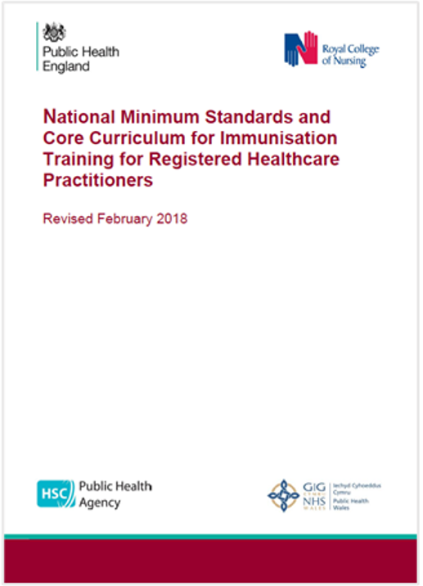

To book a webinar please use the links on the next page, further information on each session is provided at the booking link.

Primary Care Immunisation Update Webinar Series – September 2024 to January 2025
Please could all delegates ensure that:
- you only register for one webinar per monthly set to maximise space for other delegates
- if you wish to change any bookings please cancel and re-book on Eventbrite
 | Date | Start time | Link to register
September 2024 Influenza and RSV (and signposting COVID resources)
- 45 minute session plus 15 mins Q&A

1 | 05/09/2024 | 14:00 | https://September24-webinar1-InfluenzaRSVandCOVIDResources.eventbrite.co.uk
2 | 19/09/2024 | 09:30 | https://September24-webinar2-InfluenzaRSVandCOVIDResources.eventbrite.co.uk
3 | 19/09/2024 | 14:00 | https://September24-webinar3-InfluenzaRSVandCOVIDResources.eventbrite.co.uk
October 2024 Shingles and pneumococcal (adult) vaccine programmes
(and signposting to RSV resources)

1 | 02/10/2024 | 09:30 | https://October24-webinar1-ShinglesPneumococcalVaccinesandRSVResources.eventbrite.co.uk
2 | 10/10/2024 | 09:30 | https://October24-webinar2-ShinglesPneumococcalVaccinesandRSVResources.eventbrite.co.uk
3 | 10/10/2024 | 13:00 | https://October24-webinar3-ShinglesPneumococcalVaccinesandRSVResources.eventbrite.co.uk
November 2024 Adverse events following immunisation

1 | 04/11/2024 | 14:00 | https://November24-Webinar1-AdverseEventsFollowingImmunisation.eventbrite.co.uk
2 | 07/11/2024 | 09:30 | https://November24-Webinar2-AdverseEventsFollowingImmunisation.eventbrite.co.uk
3 | 14/11/2024 | 09:30 | https://November24-Webinar3-AdverseEventsFollowingImmunisation.eventbrite.co.uk
December 2024 Current issues: Routine / Infant vaccine schedule changes
– and horizon scanning

1 | 10/12/2024 | 09:30 | https://December24-Webinar1-RoutineInfantScheduleChanges.eventbrite.co.uk
2 | 12/12/2024 | 09:30 | https://December24-Webinar2-RoutineInfantScheduleChanges.eventbrite.co.uk
3 | 12/12/2024 | 13:00 | https://December24-Webinar3-RoutineInfantScheduleChanges.eventbrite.co.uk
January 2025 Legal aspects for safe vaccine administration –
consent and medicines management

1 | 09/01/2025 | 09:30 | https://January25-Webinar1-LegalAspectsConsentandMedicineManagement.eventbrite.co.uk
2 | 09/01/2025 | 13:00 | https://January25-Webinar2-LegalAspectsConsentandMedicineManagement.eventbrite.co.uk
3 | 14/01/2025 | 09:30 | https://January25-Webinar3-LegalAspectsConsentandMedicineManagement.eventbrite.co.uk

If you would like to contact the webinar team, please email: ImmsTraining@ukhsa.gov.uk

