V22

Importing The SystmOne Allowed List

SystmOne Manuals

Contents

Current Version 1

Questions or Issues 1

Save The File 1

Within SystmOne 2

On the Allowed List **Error! Bookmark not defined.**

# Current Version

**Please note that this manual will cover version 22 of the NHS NWL Allowed list published on 4th September 2024**

# Questions or Issues

Should you have any questions or issues when importing the new allowed list, please contact the NHS North West London ICT Service Desk via the NWL IT Self Service telephone 020 3350 4050 or email [Nwlccg.servicedesk@nhs.net](mailto:Nwlccg.servicedesk@nhs.net)

# Save The File

From the shared list icon below “SHARED LIST ShareInRulesAllowedList V22.shr”



Right click on the file above and click Copy

Go to your Desktop (or a specific folder/ shared drive you would like to save the document in), Right Click anywhere and Paste

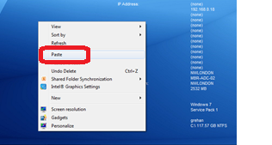

# Within SystmOne

Open SystmOne, click Setup> Users and Policy> Share in Rules

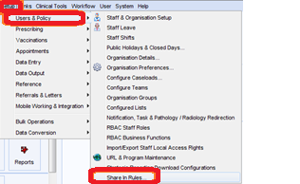

Click on Custom, then “Import”

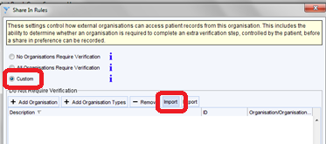

Click ‘OK’

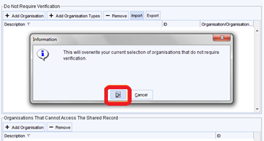

Find the file on your desktop (or relevant area saved), double click on it

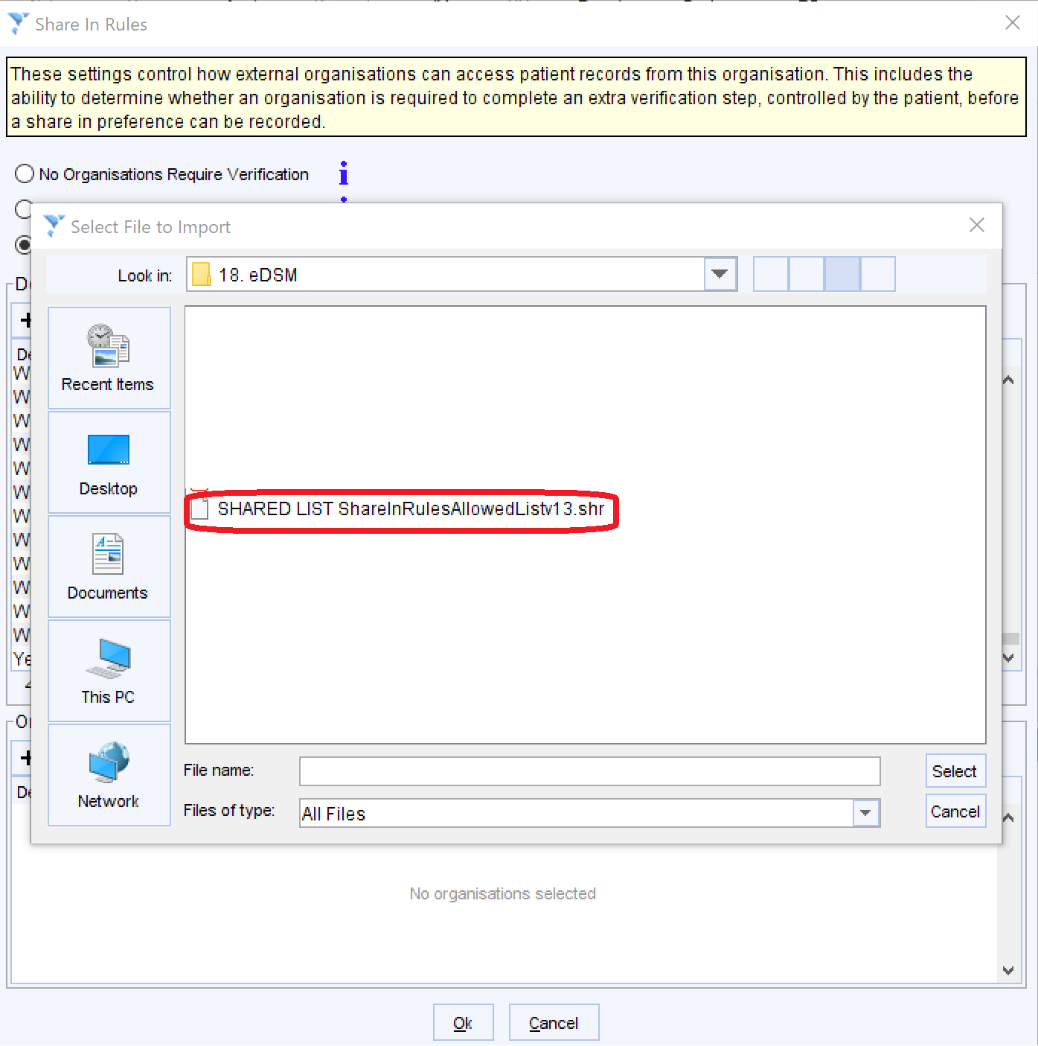

This should upload all the units into the ‘allowed list’

Once you are happy with the list, Click ‘OK’ at the bottom of the screen

