Dear GP/GP admin team,

Recent referral data has shown that a significant number of Neurosurgery (Spinal and Cranial) patients registered with NWL GPs are being referred to University College London Hospitals (part of NCL ICB). For patients to be seen at their local hospital, Imperial College Healthcare NHS Trust is the nearest NHS provider in North West London (NWL).

Following investigation and discussions with GPs, it appears that this change in referral pattern is due to a recent update in Imperial’s referral process. Imperial’s Neurosurgery service has transitioned to an Advice and Guidance (A&G) model, which has altered how Imperial appears on the e-RS system:
- When “Referral Request Type” is set to ‘Referral’, Imperial College Healthcare NHS Trust does not appear on the list of available providers.
- However, Imperial is listed and available for selection when “Request Type” is set to ‘Advice’.

Steps to select the right request type
To ensure patients continue to be referred to their local Neurosurgery service at Imperial:
- When raising a new request on e-RS for Neurosurgery (Spinal or Cranial), please select ‘Advice’ as the Request Type (as shown below on the screenshot).
- This will allow you to choose Imperial College Healthcare NHS Trust as the local provider for NWL patients
- Referrals submitted this way will be managed as usual through Imperial’s A&G pathway.

We appreciate your cooperation in helping ensure patients are directed to the correct local provider.

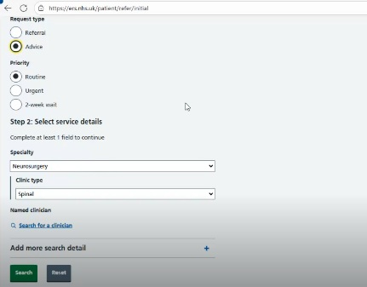

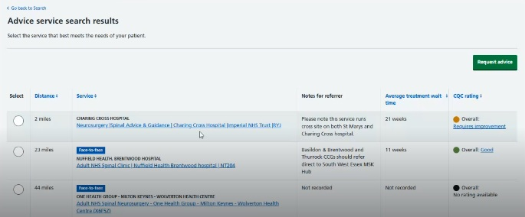

Thank you

Sanjay Gurung
Neurosurgery Network Manager - North London
Imperial College Healthcare NHS Trust
Email: sanjay.gurung@nhs.net | Phone: 07769283667

